5.83: Let the tension in the cord attached to block A be 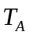 and the tension in the cord attached to block C be 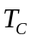. The equations of motion are then

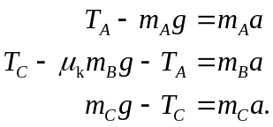
a) Adding these three equations to eliminate the tensions gives

solving for 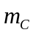 gives
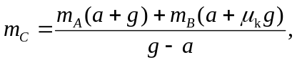
and substitution of numerical values gives 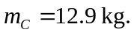
b)

